UNITED STATES
SECURITIES AND EXCHANGE COMMISSION
Washington, D.C. 20549
FORM 8-K
CURRENT REPORT
Pursuant to Section 13 or 15(d) of the Securities Exchange Act of 1934
Date of Report (Date of earliest event reported): July 22, 2026
QuantumScape Corporation
(Exact name of registrant as specified in its charter)
Delaware | 001-39345 | 85-0796578
(State or other jurisdiction  of incorporation) | (Commission File Number) | (IRS Employer  Identification No.)
1730 Technology Drive,  San Jose, California |  | 95110
(Address of principal executive offices) |  | (Zip Code)
Registrant’s telephone number, including area code: (408) 452-2000
Not Applicable
(Former name or former address, if changed since last report)
Check the appropriate box below if the Form 8-K filing is intended to simultaneously satisfy the filing obligation of the registrant under any of the following provisions:

☐ | Written communications pursuant to Rule 425 under the Securities Act (17 CFR 230.425)
☐ | Soliciting material pursuant to Rule 14a-12 under the Exchange Act (17 CFR 240.14a-12)
☐ | Pre-commencement communications pursuant to Rule 14d-2(b) under the Exchange Act (17 CFR 240.14d-2(b))
☐ | Pre-commencement communications pursuant to Rule 13e-4(c) under the Exchange Act (17 CFR 240.13e-4(c))
Securities registered pursuant to Section 12(b) of the Act:

Title of each class |  | Trading  Symbol(s) |  | Name of each exchange on which registered
Class A common stock, par value $0.0001 per share |  | QS |  | The Nasdaq Stock Market LLC
Indicate by check mark whether the registrant is an emerging growth company as defined in Rule 405 of the Securities Act of 1933 (§ 230.405 of this chapter) or Rule 12b-2 of the Securities Exchange Act of 1934 (§ 240.12b-2 of this chapter).
Emerging growth company ☐
If an emerging growth company, indicate by check mark if the registrant has elected not to use the extended transition period for complying with any new or revised financial accounting standards provided pursuant to Section 13(a) of the Exchange Act. ☐

Item 2.02 Results of Operations and Financial Condition.
On July 22, 2026, QuantumScape Corporation (the “Company”) announced its business and financial results for its second quarter of 2026, which ended June 30. A copy of the Company’s Shareholder Letter is furnished as Exhibit 99.1 to this Current Report on Form 8-K.
On July 22, 2026, the Company issued a press release announcing the release of its business and financial results. A copy of the press release is attached as Exhibit 99.2 to this Current Report on Form 8-K.
The information contained in this Item 2.02 and in the accompanying Exhibits 99.1 and 99.2 shall not be deemed “filed” for purposes of Section 18 of the Securities Exchange Act of 1934, as amended (the “Exchange Act”), or otherwise subject to the liabilities of that section, nor shall it be deemed incorporated by reference in any filing under the Securities Act of 1933, as amended, or the Exchange Act, regardless of any general incorporation language in such filing, unless expressly incorporated by specific reference in such filing.
Item 9.01 Financial Statements and Exhibits.
(d) Exhibits.

Exhibit  Number |  | Description
99.1* |  | Letter to Shareholders – Q2 Fiscal 2026 dated July 22, 2026
99.2* |  | Press Release dated July 22, 2026
104 |  | Cover Page Interactive Data File (embedded within the Inline XBRL document)

* Filed herewith.

SIGNATURES
Pursuant to the requirements of the Securities Exchange Act of 1934, the registrant has duly caused this report to be signed on its behalf by the undersigned thereunto duly authorized.

 |  | QUANTUMSCAPE CORPORATION
Date: July 22, 2026 |  | By: | /s/ Kevin Hettrich
 |  |  | Kevin Hettrich
 |  |  | Chief Financial Officer (Principal Financial and Accounting Officer)

Exhibit 99.1

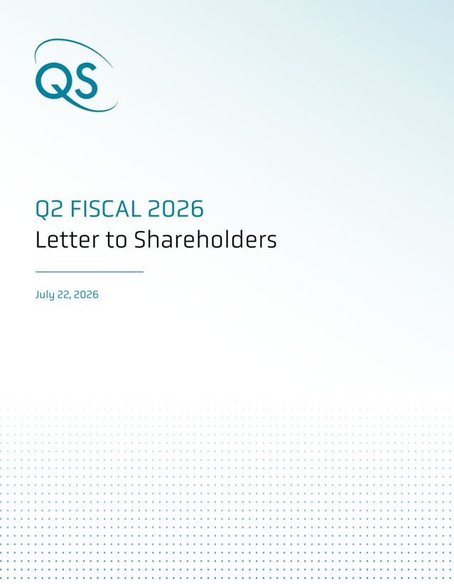
1

Dear shareholders,
We’re pleased to provide you with an update on our activities over the past quarter.
Automotive Commercialization Update

We’re proud to report that we have taken a major step forward on automotive customer engagement: on June 18, we announced a partnership with Honda. This is a multi-year agreement aimed at advancing our solid-state lithium-metal battery technology for automotive and other applications in the Honda product portfolio.
Honda is a Top-10 global automaker renowned for its engineering excellence and product quality and has made significant investments in scaling up solid-state battery manufacturing capabilities. This partnership results from one of the most rigorous assessments of our technology to date. Our ceramic separator and anode-free lithium-metal architecture enables QS to provide solutions to unlock the full potential of solid-state batteries. With Honda’s diverse product portfolio, this collaboration also allows us an additional pathway to expand into new high-value markets.

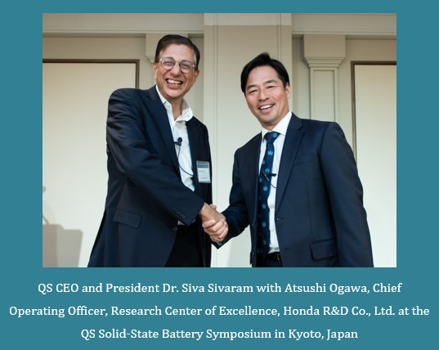 |   QS technology demonstrated compelling and unique advantages during our evaluation. We see potential for QS technology to add value across a range of applications, including automotive, and we are excited to move forward into the next phase of our partnership.  - Atsushi Ogawa, Chief Operating Officer, Research Center of Excellence, Honda R&D Co., Ltd.
QS CEO and President Dr. Siva Sivaram with Atsushi Ogawa, Chief Operating Officer, Research Center of Excellence, Honda R&D Co., Ltd. at the QS Solid-State Battery Symposium in Kyoto, Japan

Additionally, we recently updated our ongoing collaboration and licensing arrangement with Volkswagen PowerCo with an amended set of milestones and payments focused on automotive cell development, larger format cells and our future technology roadmap. We are also working with two other Top-10 automotive OEM customers under existing joint development agreements. We continue to strengthen our relationships with automakers in North America, Europe and Japan, and on this front, we have shipped cells to an additional automotive OEM customer.

2

New High-Value Markets

We see broad-based interest in our technology across a variety of applications beyond electric vehicles, including AI data centers and other advanced applications such as aerospace and defense. We believe that all these end markets can be served by our fundamental technology stack, but each customer can benefit from an individually tailored go-to-market approach. In order to serve our diverse and growing customer base, we are establishing three business verticals: QSEV for electric vehicles, QSDC for AI data centers, and QSAS for advanced solutions in applications such as aerospace and defense.
QSDC is tasked with moving rapidly to create solutions for AI data center customers based on our solid-state battery technology. As the power demands for AI compute racks approach the megawatt threshold, their power systems require innovative technologies to overcome the limitations of legacy designs. This reimagining of AI data centers is being built on the 800V DC architecture pioneered in the automotive industry, and we believe the improved energy density, power performance and safety profile of QS battery technology presents a compelling value proposition for this market. QSDC is engaged with original design manufacturers (ODMs) to design solutions based on QSE-5 technology for this fast-moving market. | QSAS is aimed at meeting the demand for better batteries in applications such aerospace and defense. In addition to valuing the energy density, power performance and safety profile of our technology, customers in this vertical place a special emphasis on limiting supply chain vulnerabilities. This presents a particular challenge for conventional Li-ion technology, the supply chain for which is dependent on graphite anode material that is almost exclusively sourced from China. In contrast, QS technology enables an anode-free lithium-metal architecture, which eliminates this supply chain risk. QSAS recently has shipped QSE-5 cells to a major American defense prime and is engaged with global players across the aerospace and defense industries.
  We welcomed Shahar Noy as Vice President and General Manager of QSDC. He has broad experience across the semiconductor and data center industries, serving at Broadcom, SanDisk, Micron, Marvell and most recently MediaTek. |   George Hart is General Manager of QSAS and Vice President of Strategy & Product. He has also held leadership positions at QS in operations and supply chain. He previously served at the RAND Corporation and holds an MBA from Harvard Business School.

3

Eagle Line Update
Work continues on one of the most important operational goals for 2026: demonstrating scalable production of QS technology using the Eagle Line, our highly automated pilot production line in San Jose. The Eagle Line serves several purposes: greater cell volumes allow us to meet customer demand for samples, higher throughput speeds up the process development cycle, and automated equipment serves as a proving ground for scaling up production.
Demonstrating scalable production of a unique technology on a first-of-a-kind automated line is a substantial challenge, and we have made significant operational progress with the Eagle Line. Core tools are showing uptime greater than 90%, key metrics of productivity are hitting our targets and we are currently ramping cell volumes and shipping samples to customers. As we continue to improve process stability and control, we aim to further double cell output in the second half of 2026 and anticipate customer sample shipments accelerating significantly across all three verticals.
We are orchestrating a network of partners within the QS technology ecosystem with the aim of scaling up cell production. As part of this effort, we are working closely with established battery equipment vendors to lay the groundwork for future factories. We also continue to collaborate with our ecosystem partners at Murata Manufacturing and Corning, working toward high-volume ceramic separator production using our Cobra process.

Technology Update
We have received consistent customer feedback that, in addition to the combination of energy density and power capability, the safety profile of our technology is highly valuable. Competing next-generation approaches, such as silicon or lithium-metal anodes with liquid electrolytes, can pose serious safety hazards. Compensating for those risks at the system level, as is the current standard, can negate most or all of the benefit of higher cell-level performance. In contrast, our proprietary ceramic separator is nonflammable and noncombustible, which enables an improved safety profile relative to lithium-ion cells.
QSE-5 Demonstrates Better Safety Than Competitor Cells
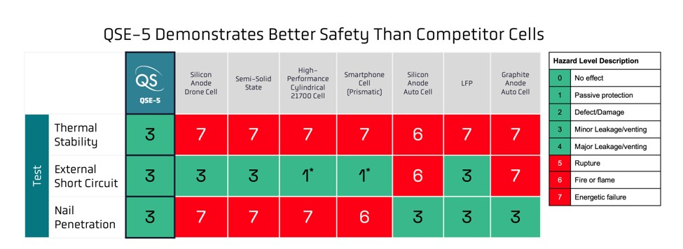
Test protocol based on IEC 62660-2 and SAE J2464. Hazard Level (HL) ≤4 is considered passing. The tests were conducted on a limited number of commercial lithium-ion cells in our labs. Not all tests were performed on every sample. *HL 1 in short-circuit testing indicates the presence of a current interrupt device incorporated into the cell design.

4

Thanks to the increased QSE-5 cell output from the Eagle Line, we are able to conduct larger-scale safety testing across a broad range of commercially relevant tests, including nail penetration, external short circuit, and thermal stability testing up to 300 °C. We are pleased to report that larger-scale testing is replicating our preliminary findings from previous generations of prototypes. We believe that our technology is a fundamentally safer design compared to both conventional and next-generation lithium-ion cells.
We have also seen customer interest for our technology in cell form factors that are larger than the QSE-5. One benefit of larger-format cells is improved packaging efficiency, which can result in higher cell-level energy density. In response to this customer interest, we have demonstrated that our Cobra process can produce larger-area separators for higher-capacity cell designs, which shows the flexibility and scalability of our ceramic separator technology to meet customer requirements.
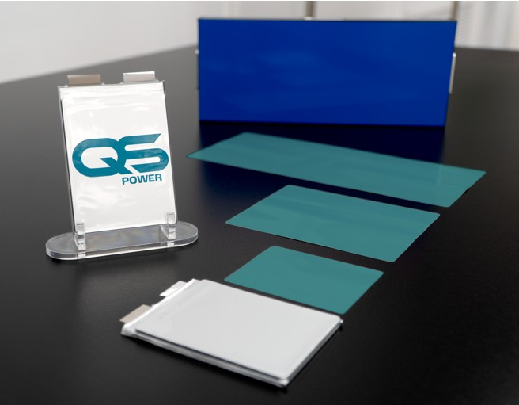 | QS ceramic separators produced by Cobra in a variety of sizes, with cell packaging for scale

Financial Outlook
GAAP operating expenses and GAAP net loss in Q2 were $106.1M and $98.2M, respectively. Adjusted EBITDA loss was $64.2M in Q2, in line with expectations. For full-year 2026, we reiterate our Adjusted EBITDA loss guidance of between $250M and $275M. A table reconciling GAAP net loss and Adjusted EBITDA is available in the financial statement at the end of this shareholder letter.
Capital expenditures in the second quarter were $4.6M. Q2 capex was primarily composed of investment into our technology roadmap and associated facility spend. For full-year 2026, we lower our guidance for capex to between $27M and $37M, reflecting capital discipline and cost savings on specific capital projects.
Customer billings in Q2 were $10.8M. Customer billings as a metric represents the total value of all invoices issued by QS to our customers and partners in the period, regardless of accounting treatment. As a reminder, customer billings may vary from quarter to quarter due to fluctuations in activity as we progress through various phases of engagement. This operational metric is not a substitute for revenue under U.S. GAAP.
5

We ended Q2 with $859.0M in liquidity and will remain prudent with our strong balance sheet going forward. As always, we encourage investors to read more on our financial information, business outlook, and risk factors in our quarterly and annual SEC filings on our investor relations website.

Strategic Outlook
QS was founded with the mission to revolutionize energy storage. Today, it’s becoming clear just how consequential that mission is for the wider world. Transportation, computing, and defense are simultaneously undergoing fundamental transformations. Electric vehicles are reshaping the global automotive market, drones and unmanned systems are rewriting the rules of defense strategy, and AI is unlocking new capabilities for every business and person on the planet. These extraordinary developments all have one thing in common: they all need better batteries.
We are positioning our organization to take advantage of these technology transformations. QSDC is working to capitalize on exciting opportunities in the AI data center market, and QSAS is engaging customers in high-value aerospace and defense applications. With QSEV, we are advancing automotive commercialization with our four Top-10 OEM customers, including the newly announced Honda partnership. The Eagle Line is ramping up to enable increased customer shipments in the second half of the year, and we are investing in our future technology roadmap, with larger-format cells and more in the pipeline.
There is much work still to do, but our team has the talent and tenacity to overcome challenges as we industrialize our technology to make the most of these transformational opportunities. Thank you for your support, and we look forward to sharing more updates in the months ahead.

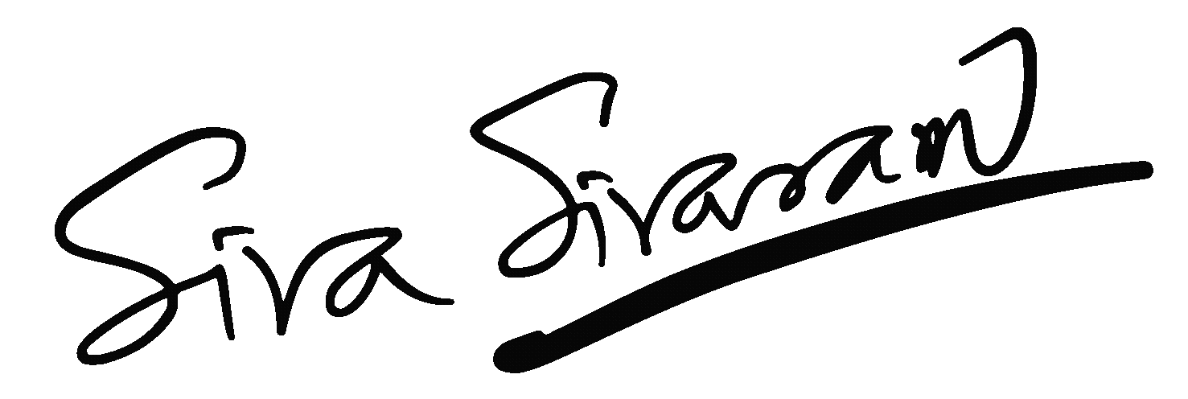 | 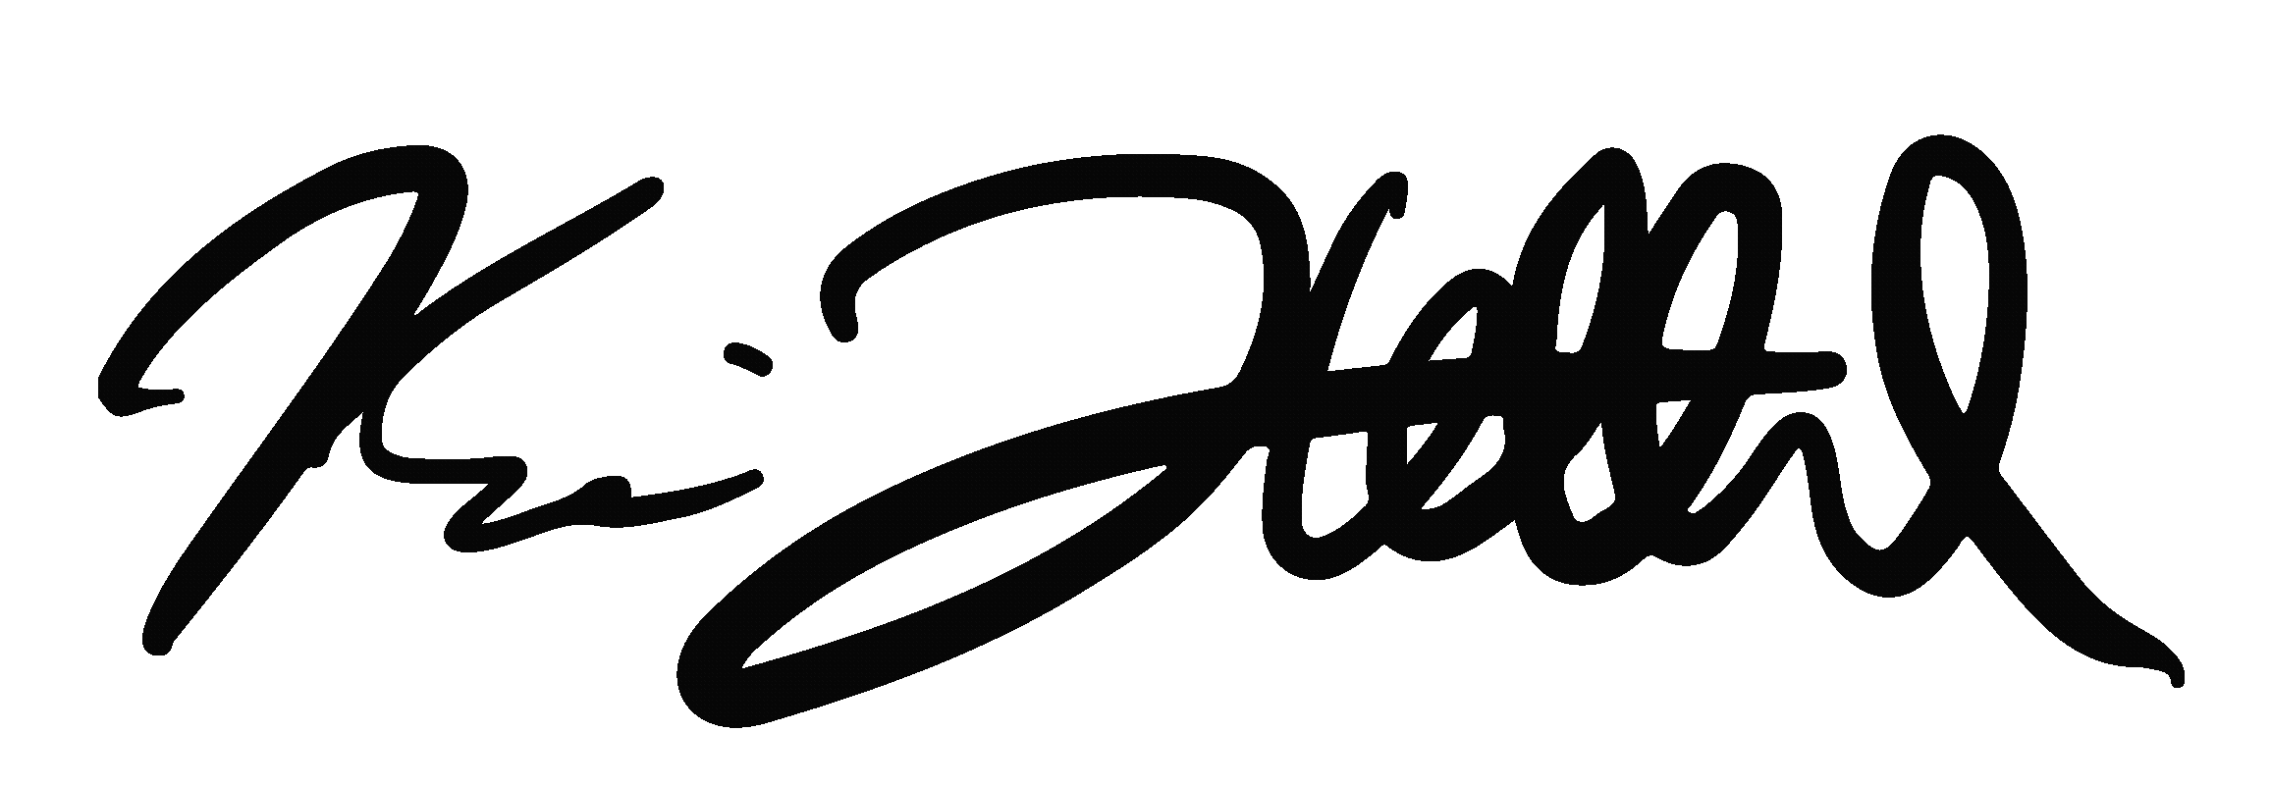
Dr. Siva Sivaram  President, CEO and Director | Kevin Hettrich  CFO

6

QuantumScape Corporation
Condensed Consolidated Balance Sheets (Unaudited)
(In Thousands)
 |  | June 30, |  |  |  | December 31,
 |  | 2026 |  |  |  | 2025
Assets
Current assets
Cash and cash equivalents |  | $ | 132,872 |  |  | $ | 230,524
Marketable securities |  |  | 726,130 |  |  |  | 740,283
Prepaid expenses and other current assets |  |  | 10,083 |  |  |  | 10,835
Total current assets |  |  | 869,085 |  |  |  | 981,642
Property and equipment, net |  |  | 229,435 |  |  |  | 251,449
Right-of-use assets - operating lease |  |  | 32,094 |  |  |  | 34,078
Right-of-use assets - finance lease |  |  | 22,451 |  |  |  | 19,394
Other assets |  |  | 15,680 |  |  |  | 21,593
Total assets |  | $ | 1,168,745 |  |  | $ | 1,308,156
Liabilities and stockholders’ equity
Current liabilities
Accounts payable |  | $ | 6,336 |  |  | $ | 11,819
Accrued liabilities |  |  | 14,961 |  |  |  | 14,521
Accrued compensation and benefits |  |  | 17,153 |  |  |  | 26,969
Operating lease liability, short-term |  |  | 4,963 |  |  |  | 4,653
Finance lease liability, short-term |  |  | 3,768 |  |  |  | 3,584
Total current liabilities |  |  | 47,181 |  |  |  | 61,546
Operating lease liability, long-term |  |  | 32,043 |  |  |  | 34,481
Finance lease liability, long-term |  |  | 26,344 |  |  |  | 28,282
Other liabilities |  |  | 15,205 |  |  |  | 14,874
Total liabilities |  |  | 120,773 |  |  |  | 139,183
Total stockholders’ equity |  |  | 1,047,972 |  |  |  | 1,168,973
Total liabilities and stockholders’ equity |  | $ | 1,168,745 |  |  | $ | 1,308,156

7

QuantumScape Corporation
Condensed Consolidated Statements of Operations and Comprehensive Loss (Unaudited)
(In Thousands, Except per Share Amounts)

 |  | Three Months Ended June 30, |  |  |  |  |  |  |  | Six Months Ended June 30,
 |  | 2026 |  |  |  | 2025 |  |  |  | 2026 |  |  |  | 2025
Operating expenses:
Research and development |  | $ | 82,533 |  |  | $ | 101,177 |  |  | $ | 167,103 |  |  | $ | 196,766
General and administrative |  |  | 23,594 |  |  |  | 22,409 |  |  |  | 48,203 |  |  |  | 50,395
Total operating expenses |  |  | 106,127 |  |  |  | 123,586 |  |  |  | 215,306 |  |  |  | 247,161
Loss from operations |  |  | (106,127 | ) |  |  | (123,586 | ) |  |  | (215,306 | ) |  |  | (247,161 | )
Other income (expense):
Interest expense |  |  | (466 | ) |  |  | (516 | ) |  |  | (944 | ) |  |  | (1,044 | )
Interest income |  |  | 8,355 |  |  |  | 8,940 |  |  |  | 17,245 |  |  |  | 18,709
Other income (expense) |  |  | 191 |  |  |  | 288 |  |  |  | 166 |  |  |  | 368
Loss before income taxes |  |  | (98,047 | ) |  |  | (114,874 | ) |  |  | (198,839 | ) |  |  | (229,128 | )
Income tax (provision) benefit |  |  | (193 | ) |  |  | 176 |  |  |  | (200 | ) |  |  | 7
Net loss |  |  | (98,240 | ) |  |  | (114,698 | ) |  |  | (199,039 | ) |  |  | (229,121 | )
Other comprehensive income (loss):
Unrealized loss on marketable securities |  |  | (610 | ) |  |  | (213 | ) |  |  | (1,638 | ) |  |  | (541 | )
Total comprehensive loss |  | $ | (98,850 | ) |  | $ | (114,911 | ) |  | $ | (200,677 | ) |  | $ | (229,662 | )
Basic and Diluted net loss per share |  | $ | (0.16 | ) |  | $ | (0.20 | ) |  | $ | (0.32 | ) |  | $ | (0.41 | )
Basic and Diluted weighted-average common shares outstanding |  |  | 617,077 |  |  |  | 561,698 |  |  |  | 614,062 |  |  |  | 554,890

8

QuantumScape Corporation
Condensed Consolidated Statements of Cash Flows (Unaudited)
(In Thousands)
 |  | Three Months Ended June 30, |  |  |  |  |  |  |  | Six Months Ended June 30,
 |  | 2026 |  |  |  | 2025 |  |  |  | 2026 |  |  |  | 2025
Operating activities
Net loss |  | $ | (98,240 | ) |  | $ | (114,698 | ) |  | $ | (199,039 | ) |  | $ | (229,121 | )
Adjustments to reconcile net loss to net cash used in operating activities:
Depreciation and amortization |  |  | 13,388 |  |  |  | 19,470 |  |  |  | 28,148 |  |  |  | 37,805
Amortization of right-of-use assets and non-cash lease expense |  |  | 2,578 |  |  |  | 2,068 |  |  |  | 5,132 |  |  |  | 4,114
Accretion of discounts on marketable securities |  |  | (3,756 | ) |  |  | (4,065 | ) |  |  | (8,254 | ) |  |  | (9,113 | )
Stock-based compensation expense |  |  | 27,325 |  |  |  | 26,255 |  |  |  | 57,834 |  |  |  | 66,894
Write-off of property and equipment |  |  | 1,225 |  |  |  | 14,847 |  |  |  | 1,857 |  |  |  | 14,888
Other |  |  | (54 | ) |  |  | (278 | ) |  |  | (232 | ) |  |  | (279 | )
Changes in operating assets and liabilities:
Prepaid expenses and other current assets and other assets |  |  | 1,226 |  |  |  | 2,636 |  |  |  | 814 |  |  |  | 3,108
Accounts payable, accrued liabilities and accrued compensation and benefits |  |  | 769 |  |  |  | (5,328 | ) |  |  | (111 | ) |  |  | (6,860 | )
Operating lease liability and other liabilities |  |  | (1,209 | ) |  |  | (2,747 | ) |  |  | (2,408 | ) |  |  | (4,025 | )
Net cash used in operating activities |  |  | (56,748 | ) |  |  | (61,840 | ) |  |  | (116,259 | ) |  |  | (122,589 | )
Investing activities
Purchases of property and equipment |  |  | (4,618 | ) |  |  | (8,586 | ) |  |  | (14,598 | ) |  |  | (14,421 | )
Proceeds from maturities of marketable securities |  |  | 282,290 |  |  |  | 256,344 |  |  |  | 514,243 |  |  |  | 537,564
Purchases of marketable securities |  |  | (245,630 | ) |  |  | (170,780 | ) |  |  | (493,466 | ) |  |  | (384,132 | )
Other |  |  | 46 |  |  |  | 278 |  |  |  | 220 |  |  |  | 278
Net cash provided by investing activities |  |  | 32,088 |  |  |  | 77,256 |  |  |  | 6,399 |  |  |  | 139,289
Financing activities
Proceeds from exercise of stock options and employee stock purchase plan |  |  | 2,993 |  |  |  | 4,477 |  |  |  | 3,607 |  |  |  | 15,659
Proceeds from issuance of common stock |  |  | — |  |  |  | — |  |  |  | — |  |  |  | 1,033
Common stock issuance costs paid |  |  | — |  |  |  | (201 | ) |  |  | — |  |  |  | (227 | )
Principal payment for finance lease |  |  | (882 | ) |  |  | (796 | ) |  |  | (1,752 | ) |  |  | (1,580 | )
Cash received under collaboration agreement - related party |  |  | 10,353 |  |  |  | — |  |  |  | 10,353 |  |  |  | —
Net cash provided by financing activities |  |  | 12,464 |  |  |  | 3,480 |  |  |  | 12,208 |  |  |  | 14,885
Net (decrease) increase in cash, cash equivalents and restricted cash |  |  | (12,196 | ) |  |  | 18,896 |  |  |  | (97,652 | ) |  |  | 31,585
Cash, cash equivalents and restricted cash at beginning of period |  |  | 158,723 |  |  |  | 171,603 |  |  |  | 244,179 |  |  |  | 158,914
Cash, cash equivalents and restricted cash at end of period |  | $ | 146,527 |  |  | $ | 190,499 |  |  | $ | 146,527 |  |  | $ | 190,499
Supplemental disclosure
Cash paid for interest |  | $ | 466 |  |  | $ | 516 |  |  | $ | 944 |  |  | $ | 1,044
Purchases of property and equipment, not yet paid |  | $ | 2,828 |  |  | $ | 7,051 |  |  | $ | 2,828 |  |  | $ | 7,051

9

Net Loss to Adjusted EBITDA
Adjusted EBITDA is a non-GAAP supplemental measure of operating performance that does not represent and should not be considered an alternative to operating loss or cash flow from operations, as determined by GAAP. Adjusted EBITDA is defined as net income (loss) before interest expense, income tax expense, non-controlling interest, revaluations, impairments, stock-based compensation, depreciation and amortization expense, and other non-recurring charges. We use Adjusted EBITDA to measure the operating performance of our business, excluding specifically identified items that we do not believe directly reflect our core operations and may not be indicative of our recurring operations. Adjusted EBITDA may not be comparable to similarly titled measures provided by other companies due to potential differences in methods of calculations. A reconciliation of Adjusted EBITDA to net loss is as follows:
($ in Thousands)  (unaudited) |  | Three Months Ended  June 30, |  |  |  |  |  |  |  | Six Months Ended  June 30,
 |  | 2026 |  |  |  | 2025 |  |  |  | 2026 |  |  |  | 2025
GAAP net loss attributable to Common Stockholders |  | $ | (98,240 | ) |  | $ | (114,698 | ) |  | $ | (199,039 | ) |  | $ | (229,121 | )
Interest expense (income), net |  |  | (7,889 | ) |  |  | (8,424 | ) |  |  | (16,301 | ) |  |  | (17,665 | )
Other expense (income), net |  |  | (191 | ) |  |  | (288 | ) |  |  | (166 | ) |  |  | (368 | )
Income tax provision (benefit) |  |  | 193 |  |  |  | (176 | ) |  |  | 200 |  |  |  | (7 | )
Stock-based compensation |  |  | 27,325 |  |  |  | 26,255 |  |  |  | 57,834 |  |  |  | 66,894
Non-GAAP operating loss |  | $ | (78,802 | ) |  | $ | (97,331 | ) |  | $ | (157,472 | ) |  | $ | (180,267 | )
Depreciation and amortization expense(1) |  |  | 14,613 |  |  |  | 34,317 |  |  |  | 30,005 |  |  |  | 52,693
Adjusted EBITDA |  | $ | (64,189 | ) |  | $ | (63,014 | ) |  | $ | (127,467 | ) |  | $ | (127,574 | )
(1) Depreciation and amortization expense includes accelerated depreciation and write-off of property and equipment no longer in use of approximately $1.2 million and $1.9 million, respectively, for the three and six months ended June 30, 2026, and approximately $14.8 million and $14.9 million, respectively, for the three and six months ended June 30, 2025.

Management’s Use of Non-GAAP Financial Measures
This letter includes certain non-GAAP financial measures as defined by SEC rules. These non-GAAP financial measures are in addition to, and not a substitute for or superior to, measures of financial performance prepared in accordance with U.S. GAAP. There are a number of limitations related to the use of these non-GAAP financial measures versus their nearest GAAP equivalents. For example, other companies may calculate non-GAAP financial measures differently or may use other measures to evaluate their performance, all of which could reduce the usefulness of our non-GAAP financial measures as tools for comparison. We urge you to review the reconciliations of our non-GAAP financial measures to the most directly comparable U.S. GAAP financial measures set forth in this letter, and not to rely on any single financial measure to evaluate our business.
10

Forward-Looking Statements

This letter contains “forward-looking statements” within the meaning of the federal securities laws based on management’s current expectations, assumptions, and available information about future events as of the date of this letter. All statements, other than historical facts, including those about the Company’s anticipated commercial and operational milestones, financial outlook, and strategic objectives, particularly concerning its battery technology development, benefits and performance, collaborations and partnerships, market expansion and goals, including the scaling of the Eagle Line and Cobra process, automotive and licensing commercialization strategies, expansion into new applications, including AI data centers, military, aerospace, and government applications, and the 2026 technology roadmap, among others, are forward-looking statements. Words like “may,” “will,” “can,” “estimate,” “permit,” “expect,” “plan,” “believe,” “designed to,” “seek,” “allow,” “focus,” “potential,” “target,” “forecast,” “should,” “would,” “could,” “continue,” “intend,” “anticipate,” “enable,” “work toward,” “prospective,” “future,” “up to,” “outlook,” “aim,” “position,” and the negative of such terms and other similar expressions identify forward-looking statements, though not all forward-looking statements include these words.

These forward-looking statements are not guarantees of future performance and are subject to a number of risks, uncertainties, and assumptions, including but not limited to, the following: Technological development risks, including significant delays or technical challenges replicating and scaling performance from earlier low-volume sample cells, achieving the quality, consistency, reliability, safety, cost, and throughput required for commercial production, developing a cell architecture meeting all technical requirements and customer expectations, or achieving further advancements beyond the QSE-5 platform or meeting the requirements of our technology roadmap; Production risks, including encountered or potential delays, unforeseen technical issues, and other obstacles in developing, acquiring, installing, and operating new equipment for automated or continuous flow processes like Cobra and the Eagle Line, including vendor delays, supply chain disruptions, and challenges in demonstrating scalable cell output on the Eagle Line or achieving the efficiencies necessary to support customer integration; Personnel risks, including potential delays and cost overruns in hiring and retaining the talent needed to expand development and production, including under the amended Collaboration Agreement with PowerCo; Infrastructure and supply chain risks, including challenges building out or scaling the Eagle Line and establishing supply relationships for required materials, components, or equipment, including in contract manufacturing relationships; Commercialization risks, where delays in increasing sample production have previously slowed our development, and such delays could affect our sample delivery and delay or prevent successful demonstration, commercialization of our products, field testing, tailored product solutions for vehicle programs, entry into the IP License Agreement with PowerCo, or engagement with new partners across the battery value chain; Risks related to our customer relationships, with Volkswagen and PowerCo, Honda, and our other automotive OEM partners, which could adversely affect our business and future prospects, including potential delays, difficulties, and technical challenges collaborating to industrialize our battery technology; Milestone and licensing risks, including delays or difficulties meeting technical milestones, particularly those linked to program payments or required to trigger entry into the IP License Agreement and royalty prepayment, or difficulties in achieving the performance, quality, consistency, reliability, safety, cost and throughput required for commercial production and sale, scaling up the Eagle Line as a manufacturing blueprint to enable licensing partners to successfully bring our technology to gigawatt-hour scale in their own facilities, or readying our technology platform for transfer to prospective licensees, any of which could cause prospective customers and partners not to purchase cells or license our technology; Operational and commercial restrictions, as certain agreements and relationships currently or may in the future restrict our operations, commercialization, and revenue; Partnership and collaboration risks, as while our collaboration with Murata Manufacturing, Corning Incorporated, and other partners across the battery value chain could accelerate industrialization of our solid-state battery technology, there is no assurance these engagements, including investment in QS-proprietary hardware and systems, will progress beyond initial phases or achieve intended outcomes; Cost control risks, including the inability to control costs tied to our operations and the components needed to build solid-state battery cells at competitive prices; Financial risks, including exceeding current spend expectations, actual results differing materially from our financial guidance, including our full-year Adjusted EBITDA loss and capital expenditure guidance, requiring additional fundraising, including in public markets, which may dilute our investors’ ownership, or related to our customer billings, such as disputes or delays in payments and the consistency of billings; Market and economic risks, including the inability to successfully adapt our technology for or penetrate new high-value markets beyond the automotive sector, including AI data centers, military, aerospace, and government applications, many of which remain at an early stage of customer engagement, with no assurance that customer interest will convert to development agreements, purchase commitments, or revenue, difficulties from changes in our economic and financial conditions, market conditions affecting demand for our technology, regulatory changes or changes to broader economic conditions, among other factors, potentially hindering success in the battery industry or undermining confidence in our long-term business among partners and customers; Competition risks from major manufacturers, automotive OEMs, and new entrants, including conventional lithium-ion battery suppliers, in developing and commercializing solid-state battery technology; and Intellectual property risks, where the inability to protect or assert our intellectual property could harm our business and competitive position.

The foregoing list of factors is not exhaustive. We caution readers not to place undue reliance on any forward-looking statements, which speak only as of their date. Except as required by law, we disclaim any duty to update forward-looking statements. If assumptions prove incorrect, actual results and projections could differ materially from those in forward looking statements. Additional information about these and other factors that could materially affect our actual results can be found in our SEC filings, available at www.sec.gov.
11

Exhibit 99.2

QuantumScape Reports Second Quarter 2026 Business and Financial Results

SAN JOSE, Calif. – July 22, 2026 – QuantumScape Corporation (NASDAQ: QS), a global leader in next-generation solid-state lithium-metal battery technology, today announced its business and financial results for the second quarter of 2026, which ended June 30.

The company posted a letter to shareholders on its Investor Relations website, ir.quantumscape.com, that details second-quarter financial results and provides a business update.

QuantumScape will host a live webcast today at 2 p.m. Pacific Time (5 p.m. Eastern Time), accessible via its IR Events page. Siva Sivaram, chief executive officer, and Kevin Hettrich, chief financial officer, will participate on the call.

An archive of the webcast will be available shortly after the call for 12 months.

About QuantumScape Corporation

QuantumScape is on a mission to revolutionize energy storage to enable a sustainable future. The company’s next-generation batteries are designed to enable greater energy density, faster charging and enhanced safety to support the transition away from legacy energy sources toward a lower carbon future. For more information, visit www.quantumscape.com.

For Investors
ir@quantumscape.com

For Media
media@quantumscape.com

